
Focus Brain Therapy
June 16, 2026
Concept/Mockup – Client Feedback
Meeting with Dr. Lisa and Marcy

Existing Client website: https://focusbraintherapy.com/
Concept/Mockup: https://focusbrain-kappa.vercel.app/
HOME
- The client sent a new logo and see if this one is better so you size it without it being distorted and will look good on the website.
- The client would like it on top of the page and also somewhere in this section.
Change text to: (2 lines)
Medicare and PPO Insurance accepted
Financing available
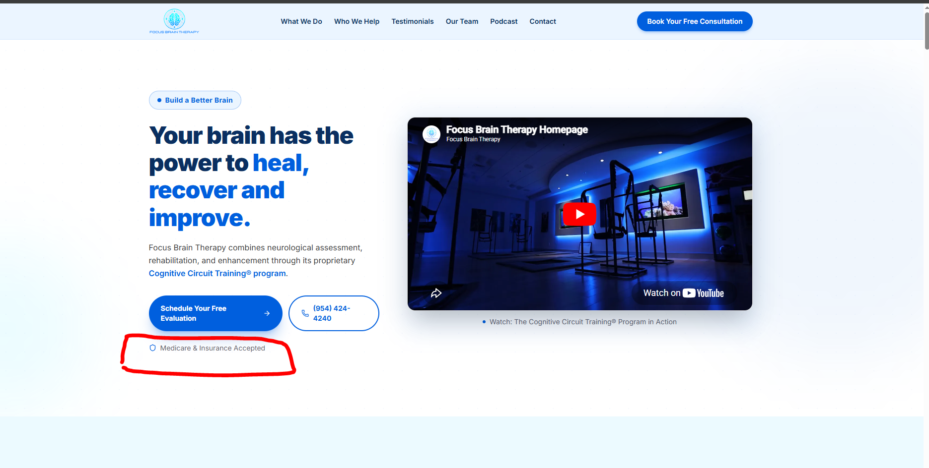
- Create another bullet/blue area so there will be 2:
- Build a Better Brain
- Build a Better Life
- Rename button to: Schedule Your Free Consultation (not Evaluation)
- Make phone number button a little longer so it is all on one line.
- Possibly move these two buttons across the bottom of the page.
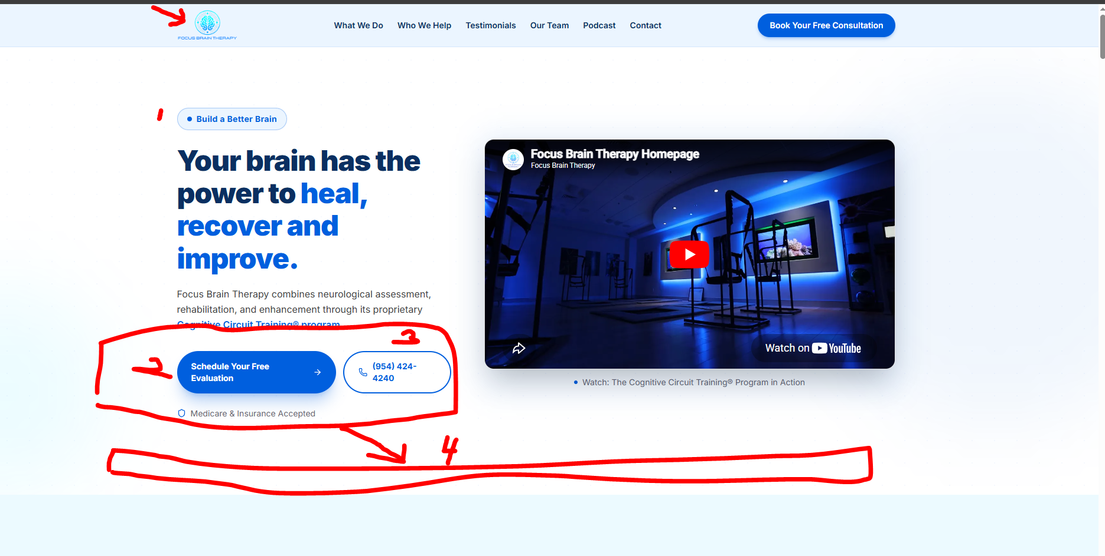
New Logo:


Change this text to: Cognitive Circuit Training® (CCT)
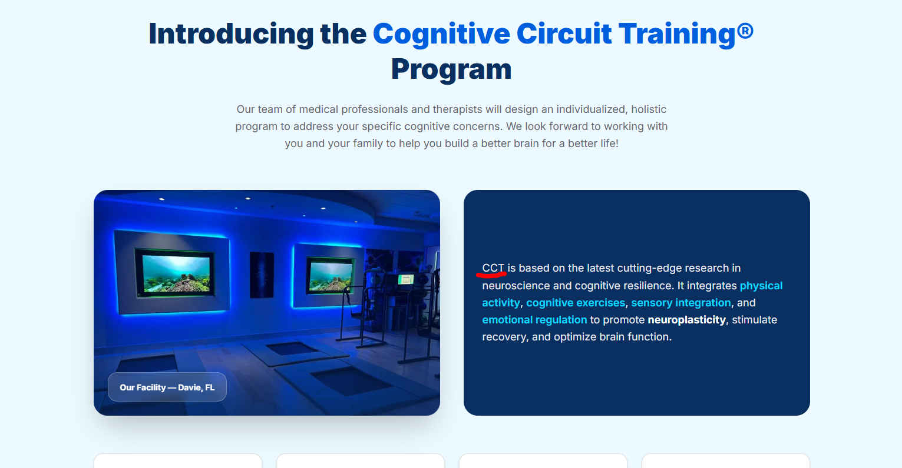

Reword this as follows on 2 lines with line 2 being a smaller font size and centered under line 1.
Our team is here for you.
Whether you’re recovering from an injury or proactively supporting your brain health.
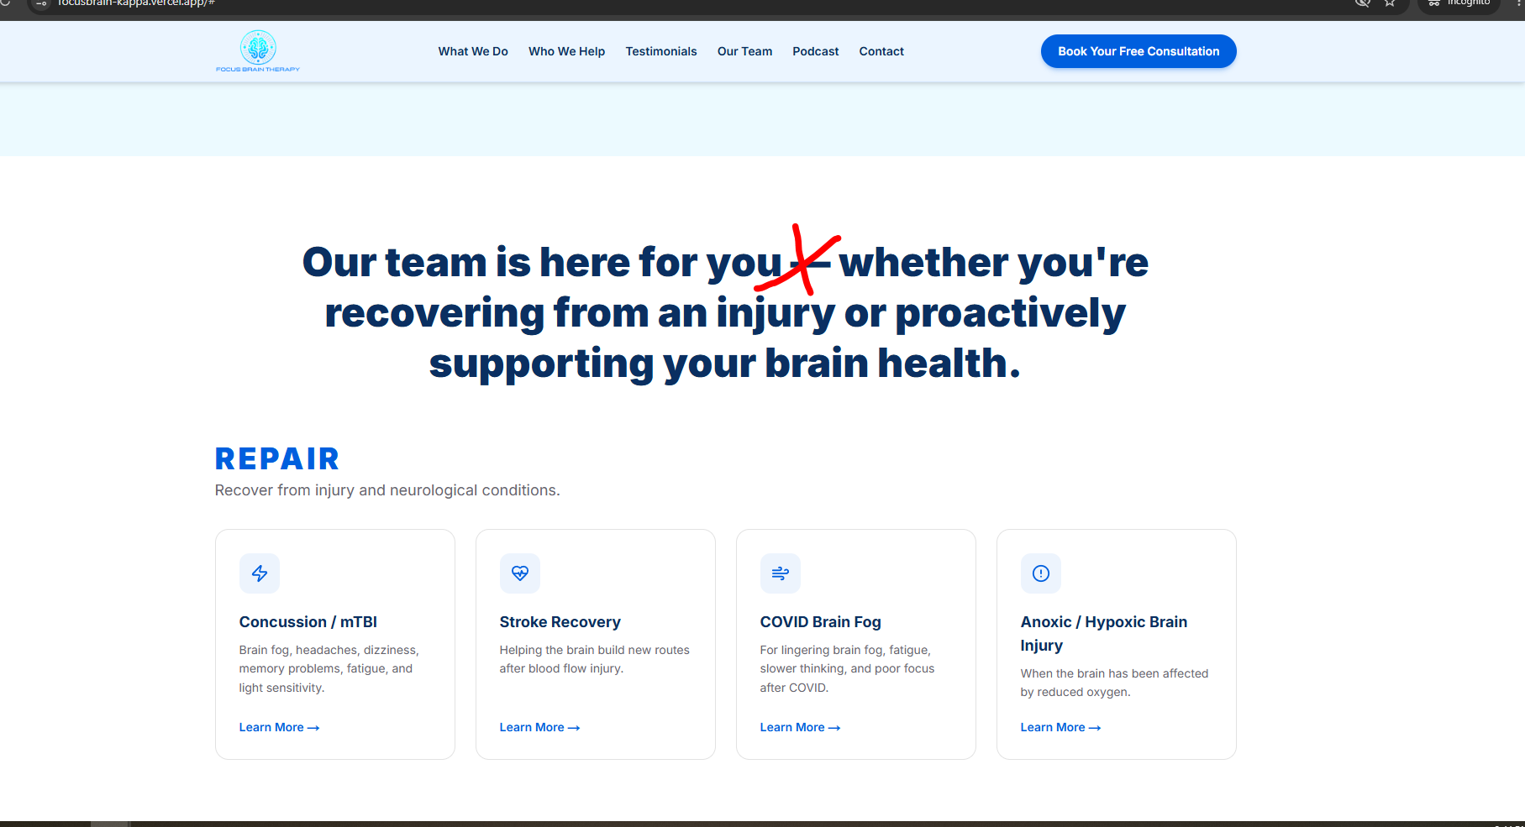
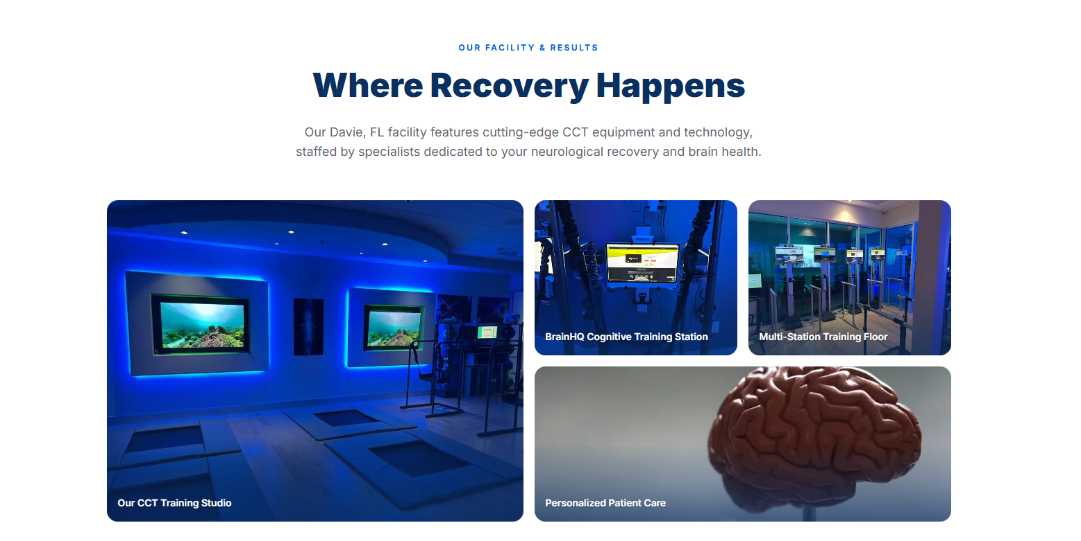
- Swap out all images with these.
- Not titles or names are needed on the images.

New Images
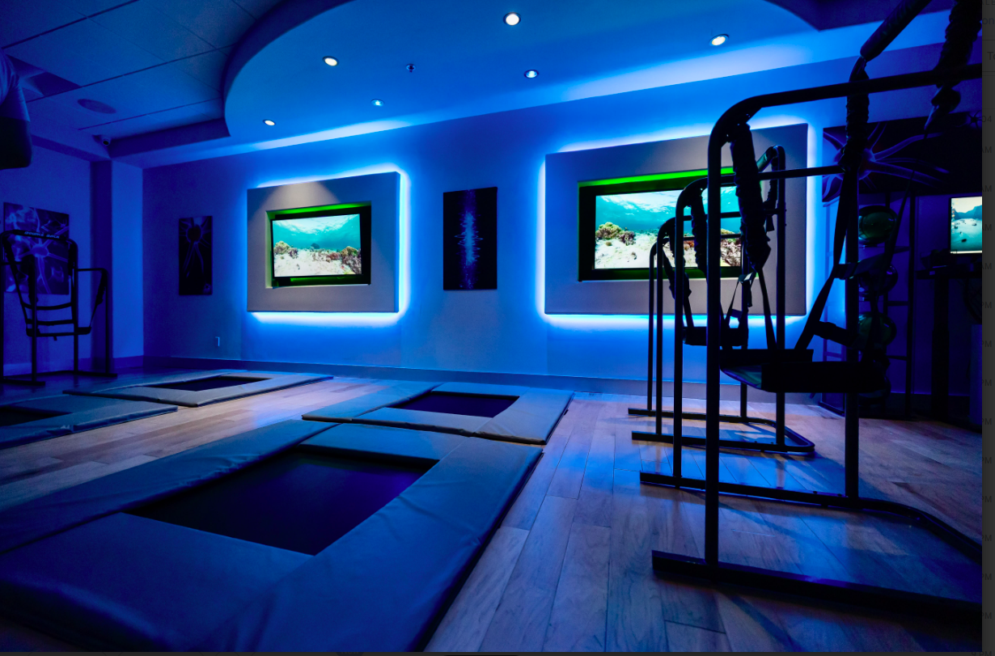
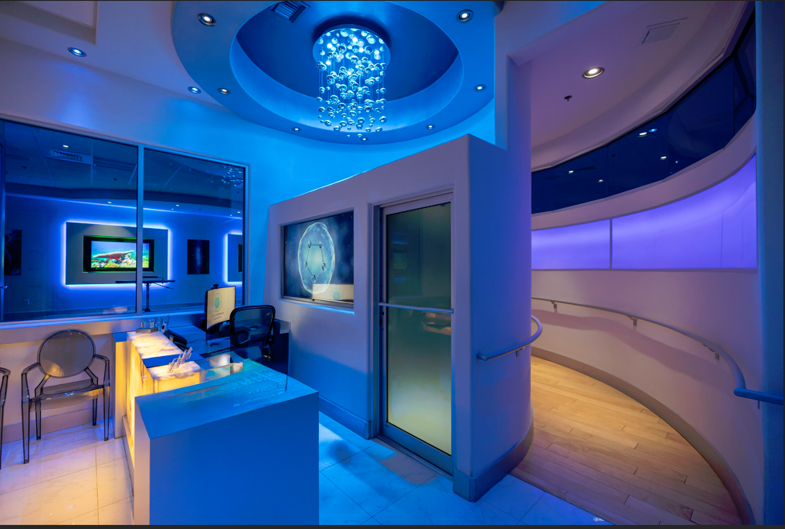
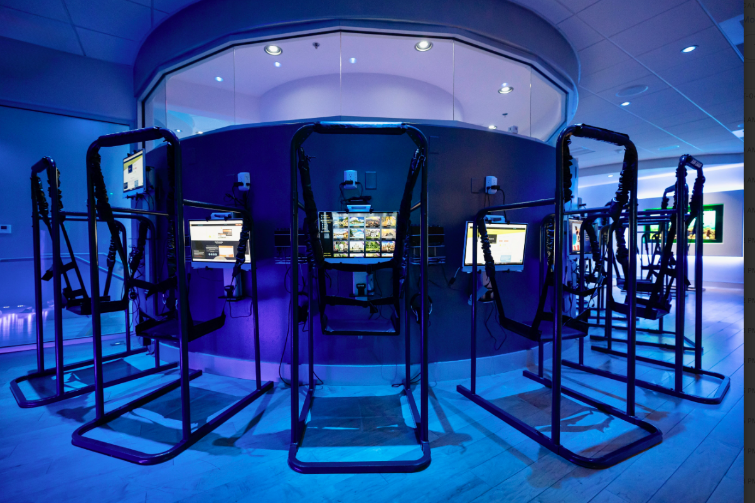
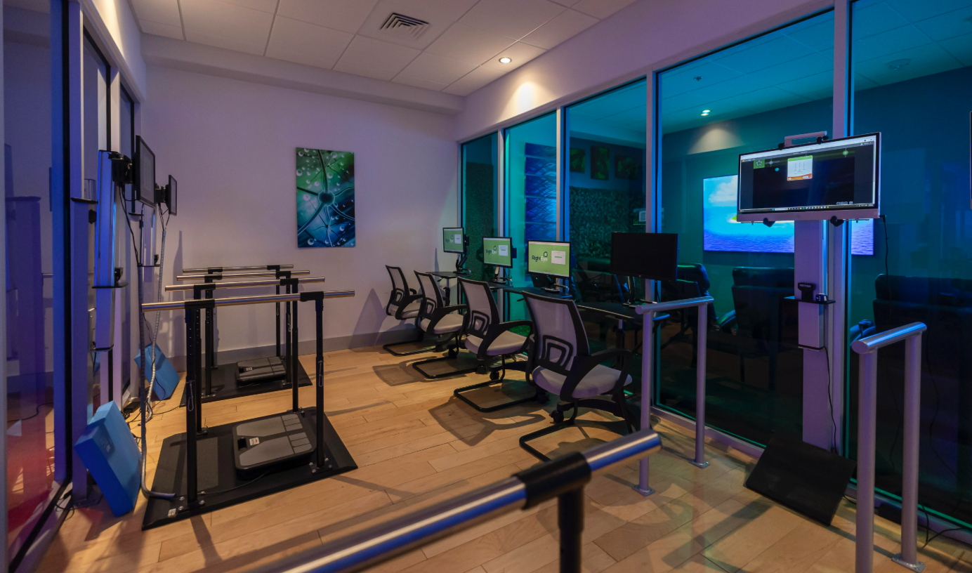
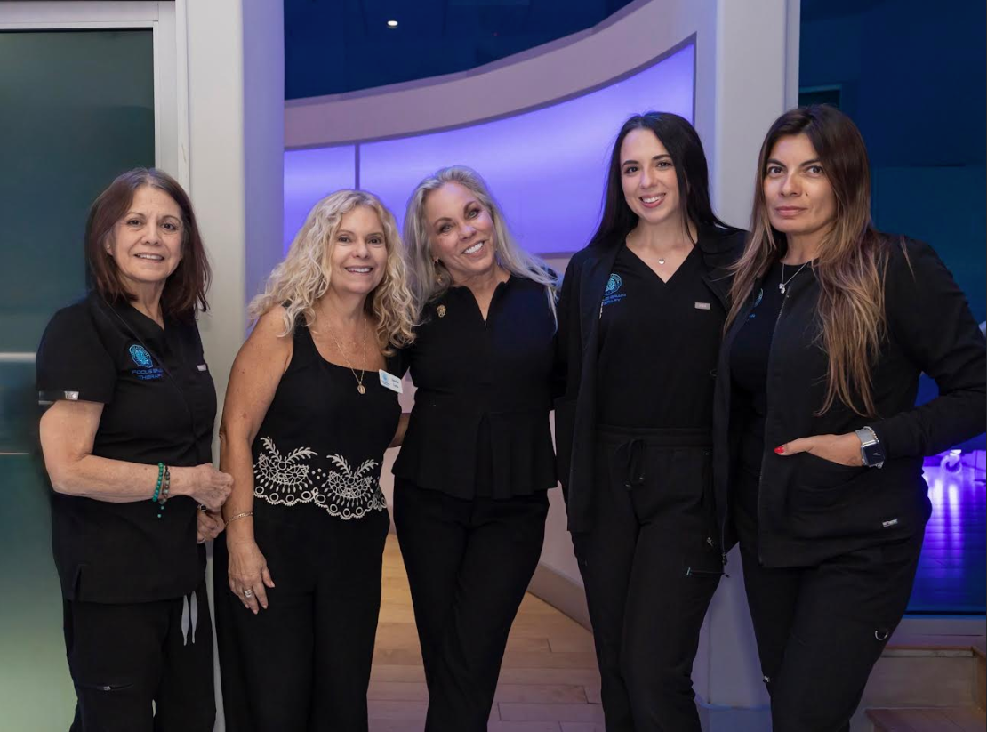

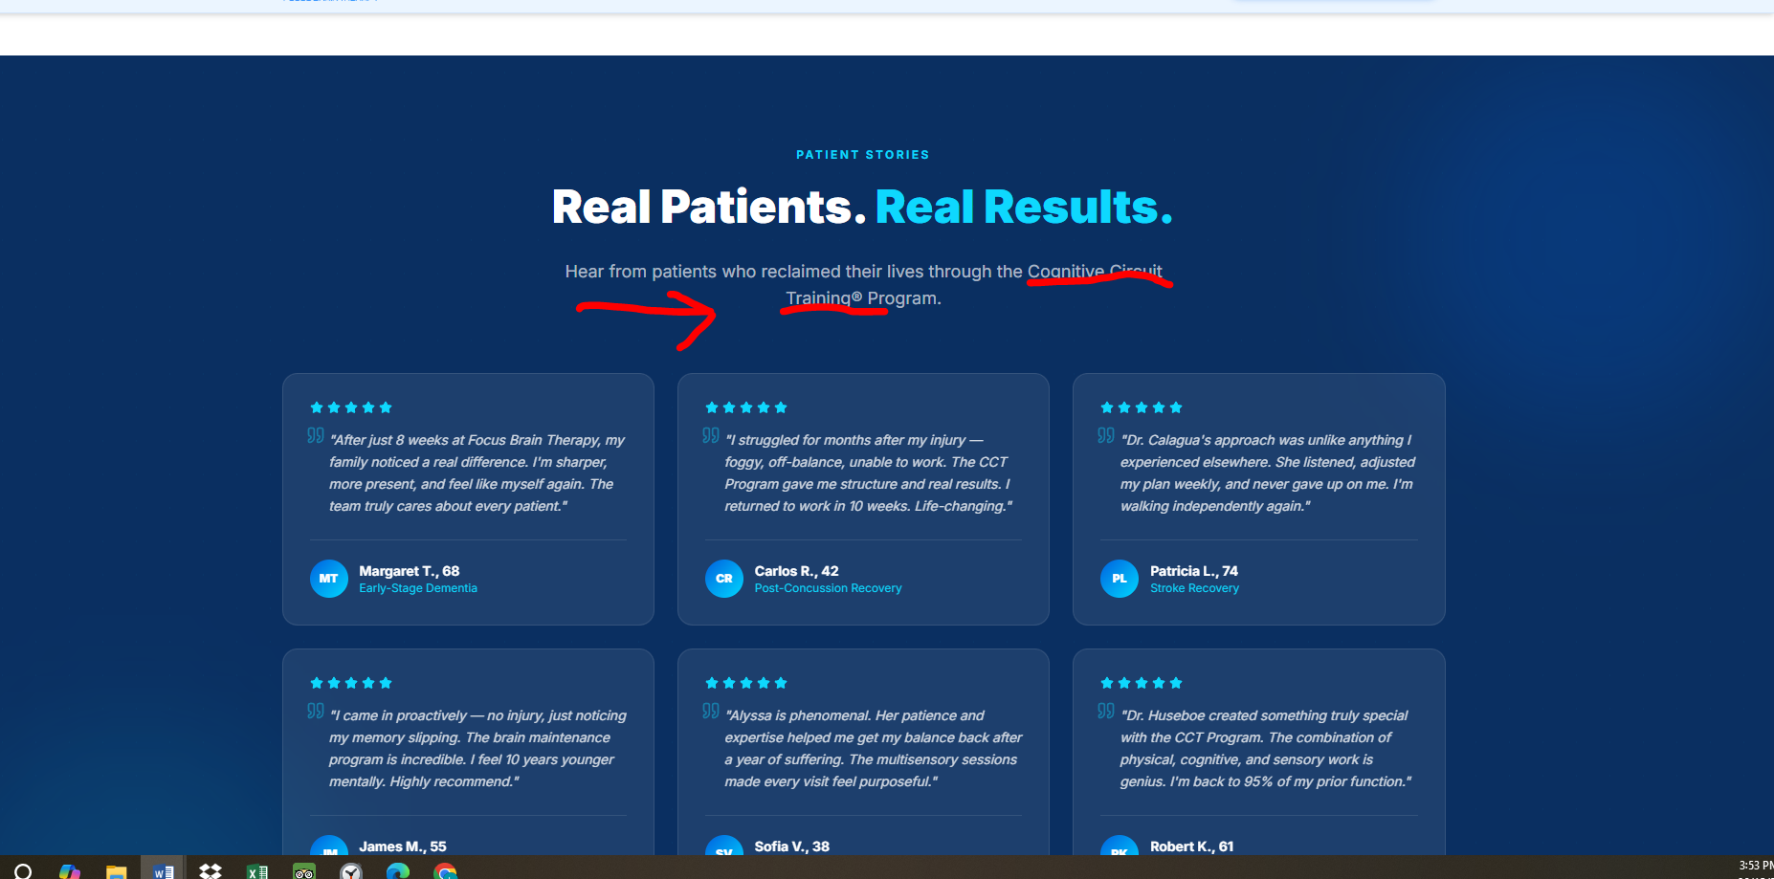
Change sub-title to make it on two lines and center under the title:
Hear from patients who reclaimed their lives through the
Cognitive Circuit Program
- Replace all the testimonials and replace with the ones on Google.
- Remove any names or reference that says Neurocity Junction.
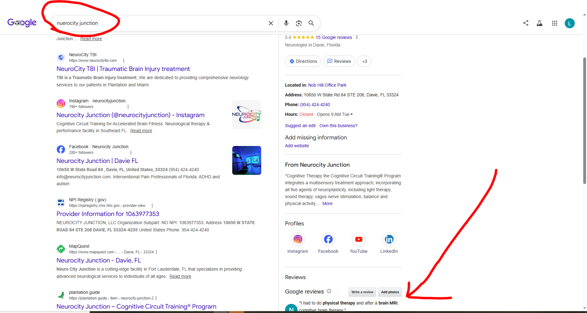

Place the 5 stars on the website with arrows to see more if there are too many on the website. Not sure how many rows you need to have so it looks nice.
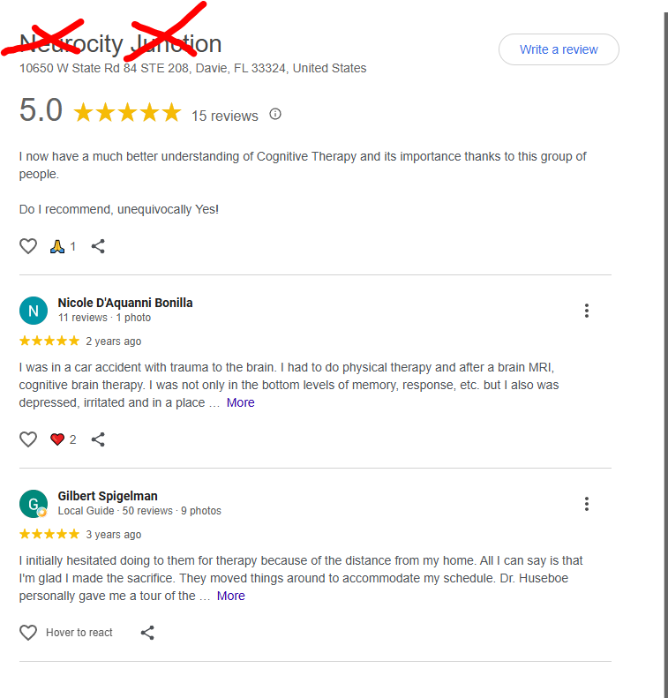
Change text to: Build a better brain to build a better life.
Don’t make it clickable.

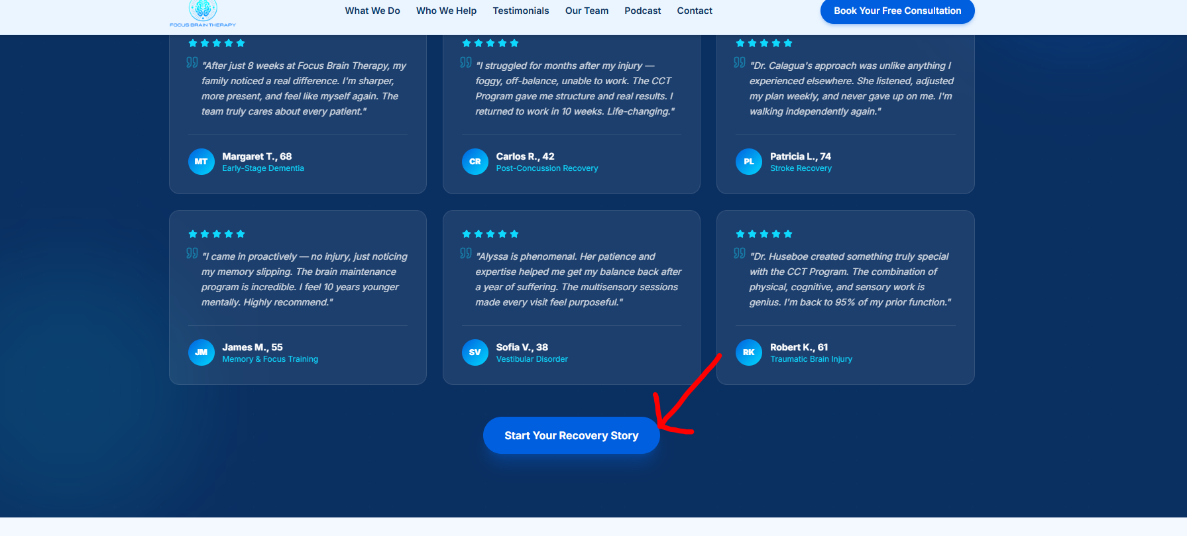

Change text and center it under title to:
Medicare, PPO Plans, State Workers’ Compensation, Federal Workers’ Compensation
Financing Available

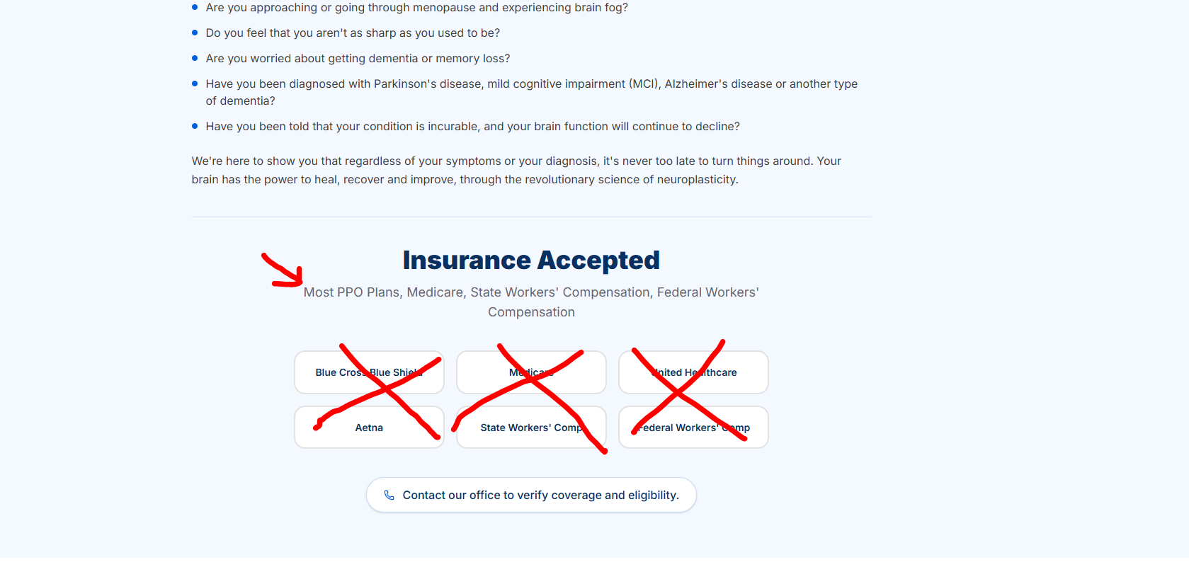
FOOTER
- Add logo to footer
- Remover the F in a circle
- Change to: Focus Brain Therapy (Not all caps)
- Make sure the Quick Links menu matches the top menu bar
- Remove the Social Media Links for now
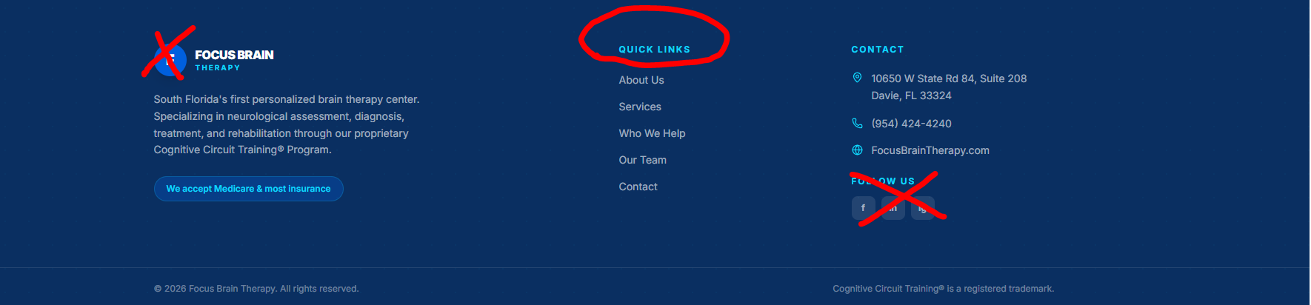

Change and center text under title to the following;
Make line one a little smaller than the title in italics.
Example:

Start Your Recovery Today
Schedule a free consultation.
Our team is here to guide you and coach you every step of the way.
